Disease Prediction & Health Analytics System

Project Overview
The Disease Prediction & Health Analytics System is a data-driven healthcare analytics platform designed to assist hospitals and clinics in predicting diseases, monitoring patient health trends, and identifying abnormal health patterns using statistical and scientific computing.

Modern hospitals generate large volumes of patient data (blood pressure, glucose, cholesterol, heart rate, age, symptoms, etc.), but this data is rarely analyzed for early disease detection. This project bridges that gap by applying NumPy, Pandas, SciPy, and Matplotlib to convert raw hospital data into meaningful medical insights.

Problem Statement
Most hospitals store patient data in digital files (CSV, Excel, or databases), but:

  - They do not perform deep analysis
  - Diseases are detected only after symptoms become severe
  - Doctors have no visual trend reports
  - Risk prediction is done manually This leads to:
  - Late diagnosis
  - Increased treatment cost
  - Higher patient mortality

Proposed Solution
The system will analyze patient medical records and:

  - Predict the probability of diseases such as:
    - Heart disease
  - Detect abnormal values
  - Identify high-risk patients
  - Visualize hospital health trends The system provides doctors with:
  - Automated risk scores
  - Disease probability

  - Interactive medical graphs

- System Architecture:
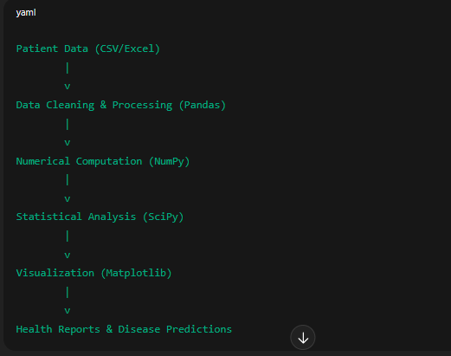

Dataset Description
Each patient record contains:

Field | Description
Patient_ID | Unique patient identifier
Age | Patient age
Gender | Male / Female
Blood_Pressure | BP level
Sugar_Level | Blood glucose
Cholesterol | Cholesterol level

Field | Description
Heart_Rate | Beats per minute
BMI | Body mass index
Disease_Label | (0 = Normal, 1 = Disease)

Role of Each Library
Pandas

  - Load CSV / Excel medical data
  - Remove missing values
  - Filter patients by age, gender, or disease
  - Group by hospital departments

NumPy

  - Perform mathematical operations
  - Calculate averages, deviations
  - Convert datasets into arrays
  - Compute health risk scores

SciPy

  - Perform statistical tests
  - Correlation between BP and heart disease
  - Probability of diabetes
  - Regression analysis for disease prediction

Matplotlib

  - BP vs Age graphs
  - Sugar level trends
  - Disease frequency charts
  - Hospital-wise reports

Disease Prediction Model
The system uses statistical regression and probability models:

  - Linear Regression (SciPy)

  - Correlation Analysis
  - Mean, Variance & Standard Deviation
  - Risk thresholding

Example:
If

Sugar > 180
BP > 140
BMI > 30

→ High diabetes risk

The system automatically flags such patients.

Key Features
Patient Health Analysis

  - Identify abnormal BP
  - Detect high sugar
  - Monitor heart rate

Disease Prediction

  - Heart disease risk

Hospital Analytics

  - Monthly disease trend
  - Age-wise illness distribution
  - Gender-wise health patterns

Visualization Dashboard

  - Line charts
  - Bar graphs
  - Risk heatmaps

Sample Output
Doctors will see:

  - Bar chart of heart disease by age
  - Patient-wise risk score
  - Alert for high-risk patients

Applications
  - Hospitals
  - Clinics
  - Health insurance companies
  - Government health departments
  - Medical research institutes

Future Enhancements
  - Machine Learning models
  - Real-time patient monitoring
  - Integration with hospital databases
  - AI-based diagnosis
  - Mobile app for doctors

System Flow Diagram:

┌──────────────────────┐
│ Patient Dataset │
│ (CSV / Excel) │
└──────────┬───────────┘
│
▼
┌──────────────────────┐
│ Data Cleaning │
│ (Pandas) │
│ Remove nulls │
│ Fix formats │
└──────────┬───────────┘
│

▼
┌──────────────────────┐
│ Numerical Analysis │
│ (NumPy) │
│ Mean, Std, BMI │
└──────────┬───────────┘
│
▼
┌──────────────────────┐
│ Statistical Model │
│ (SciPy) │
│ Regression, Risk │
└──────────┬───────────┘
│
▼
┌──────────────────────┐
│ Disease Prediction │
│ Risk Classification │
└──────────┬───────────┘
│
▼
┌──────────────────────┐
│ Data Visualization │
│ (Matplotlib) │
└──────────┬───────────┘
│
▼
┌──────────────────────┐
│ Health Reports │

│ Doctor Dashboard │
└──────────────────────┘

2. Sample Dataset (CSV Format) You can save this as patients.csv
Age,Sex,Chest pain type,BP,Cholestrol, FBS over 120, EKG results,Max HR,Exercise angina, ST depression,Slope of ST, Number of vessels fluro, Thallium, Heart Disease
70,1,4,130,322,0,2,109,0,2.4,2,3,3, Presence
67,0,3,115,564,0,2,160,0,1.6,2,0,7, Absence
57,1,2,124,261,0,0,141,0,0.3,1,0,7, Presence
64,1,4,128,263,0,0,105,1,0.2,2,1,7, Absence
74,0,2,120,269,0,2,121,1,0.2,1,1,3, Absence

Code Structure:
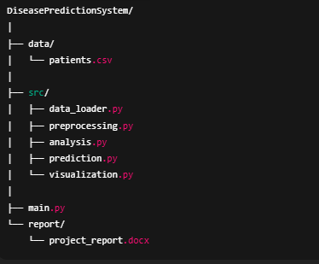
Module Responsibilities
File | Purpose
data_loader.py | Load CSV using Pandas
preprocessing.py | Clean and normalize data
analysis.py | NumPy & SciPy calculations
prediction.py | Disease probability
visualization.py | Graphs
main.py | System controller

Chapter 1 – Introduction Background of healthcare analytics

- Importance of disease prediction
- Objectives of the project
- Scope of the system

Chapter 2 – Literature Review Existing hospital systems

- Traditional diagnosis methods
- Gaps in current solutions

Chapter 3 – System Analysis Problem definition

- Feasibility study
- Functional requirements
- Non-functional requirements Chapter 4 – System Design Architecture
- Data flow diagram
- Database design
- Algorithm design

Chapter 5 – Implementation Pandas data processing

- NumPy calculations
- SciPy statistical model
- Matplotlib visualization

Chapter 6 – Results & Discussion Graph outputs

- Prediction accuracy
- Health trend analysis

Chapter 7 – Conclusion & Future Work Achievements

- Limitations
- Future enhancements

Why this project scores high This project demonstrates:

- Data Science
- Healthcare Analytics
- Statistical Modeling
- Real-world applicability It meets:
- Academic value
- Industry relevance
- Research capability

